Four R packages for Automated Exploratory Data Analysis you might have missed

Explore useful tools to ease exploratory tasks through practical examples in R
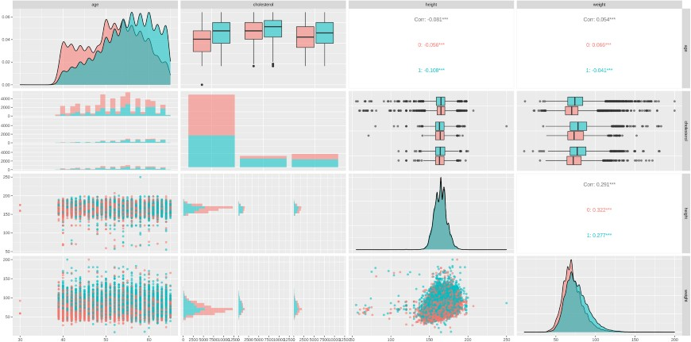
Image by author.

Table of contents
- Introduction
- Automated Exploratory Data Analysis packages
  - DataExplorer
  - GGally
  - SmartEDA
  - tableone
- Conclusions
- References

Introduction
Exploratory Data Analysis (EDA) aims at performing an initial investigation on the data by summarizing their characteristics through statistical and visualization techniques, and it is a critical early step in any Data Science workflow.
In this post, we explore four R packages that facilitate this initial task and provide a substantial support in data handling, visualization and reporting.
For this example, we use the Cardiovascular Disease Dataset¹, composed of the following features:
- id: unique patient identifier (int)
- gender: gender of the patient (1: female, 2: male)
- age: age in days (int)
- height: height in cm (int)
- weight: weight in kg (float)

- ap_hi: systolic blood pressure (int)
- ap_lo: diastolic blood pressure (int)
- cholesterol: cholesterol (1: normal, 2: above normal, 3: well above normal)
- gluc: glucose (1: normal, 2: above normal, 3: well above normal)
- smoke: whether patient smokes or not (binary)
- alco: alcohol intake (binary )
- active: physical activity (binary)
- cardio: presence or absence of cardiovascular disease (binary) We load the dataset and observe the first rows:
# install.packages("tidyverse") library(dplyr)
library(readr)

# read csv file df <-
read_delim(
file = "/data/cardio_train.csv", col_types = "iifidiiffffff", delim=";")

# pre-processing df <-
# remove the id select(df, -id) %>% # age: days -> years
mutate(age = round(age / 365))

# observe first rows head(df)
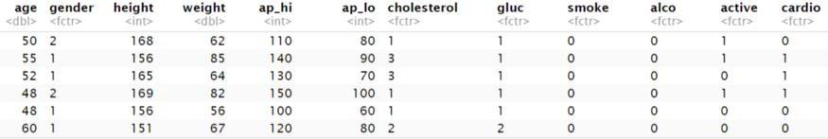
Image by author.
Base R provides summary², a generic function used to produce result overviews from different input objects, such as datasets. In particular, when a dataset is provided as input (e.g. summary(df)), it returns different metrics (such as mean, median, min, max, …) for numeric columns, and the distribution (counts) for categorical columns. It also returns information about missing data, if present:
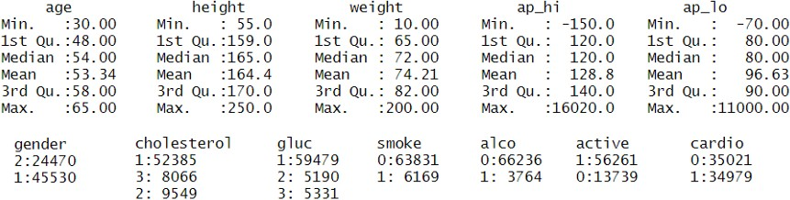

Output of summary(df). Image by author.
Now, let us jump to packages that provide further data exploration capabilities.

Automated Exploratory Data Analysis packages

DataExplorer
DataExplorer³ simplifies and automates the EDA process and report generation. The package automatically scans through each variable performing data profiling, and it offers several helpful functions to generate different charts on both discrete and continuous features.
Importantly, the package allows to generate a complete HTML report without effort by invoking the helpful create_report function on a dataset (e.g. create_report(df)). It is possible to pass additional arguments, such a response variable y, to add various bivariate analyses to the report:
The snippet produces an HTML file in the working directory. When opened with a browser, it appears as follow:
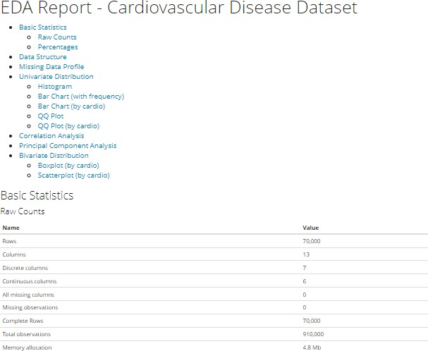
The early part of the HTML report, comprehensive of table of contents. Image by author.
As it can be seen from the table of contents, the report covers most of the tasks performed during EDA, and it can be generated by a single line of code.
Additional package functions for specific tasks are reported as example:
- plot_str(df) plots the dataset structure:

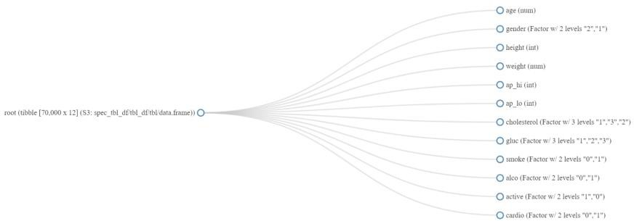

Output of plot_str(df). Image by author.
- plot_bar(df) plots the bar chart for each discrete feature:
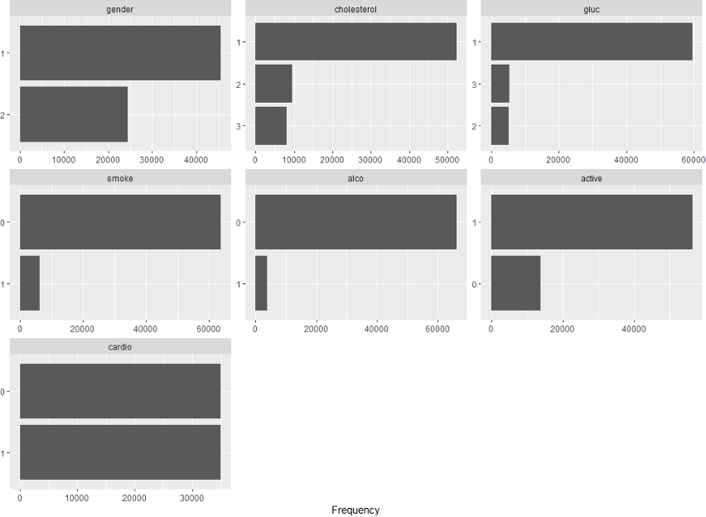

Output of plot_bar(df). Image by author.
- The charts can also be grouped by a discrete variable, e.g. the presence of a cardiovascular disease, by: plot_bar(df, by="cardio"):

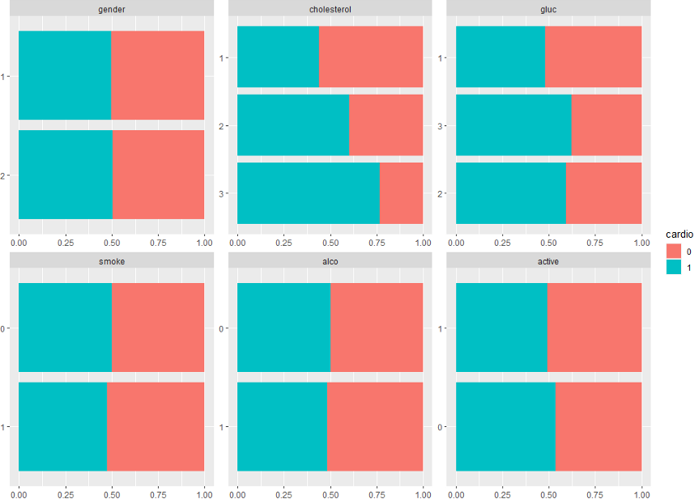

Output of plot_bar(df, by=”cardio”). Image by author.
By observing the plots, one may immediately notice that patients with cardiovascular disease present higher values of cholesterol and may be induced to further investigate the risk of cardiovascular disease represented by higher cholesterol through statistical testing.
- plot_qq(df) plots quantile-quantile for each continuous feature:
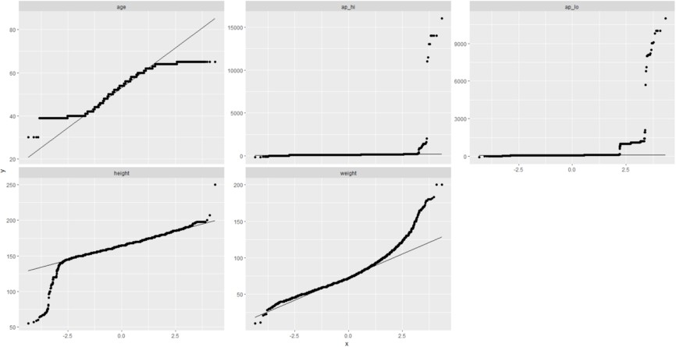
Output of plot_qq(df). Image by author.
By observing the first QQ plot (age), for example, one may notice that the points tend to curve at the extremities, indicating that age has more extreme values that it would have if it had a normal distribution (this behaviour falls under the name of “heavy tails”).
- plot_density(df) plots density estimates for each continuous feature:

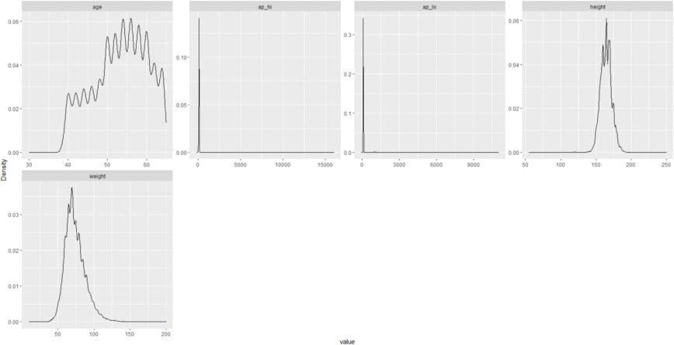

Output of plot_density(df). Image by author.
- plot_correlation(df) to visualize correlation heatmap:
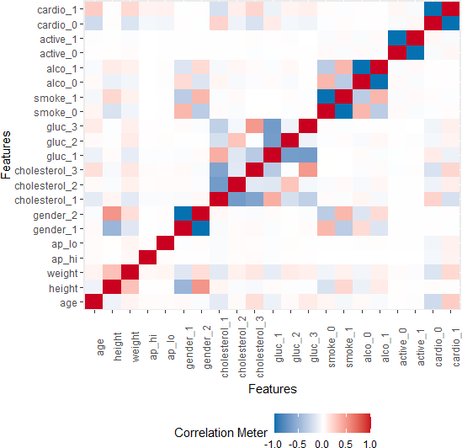

Output of plot_correlation(df). Image by author.
- plot_prcomp(df) performs Principal Component Analysis (PCA) and plots the percentage of variance explained by each principal component:

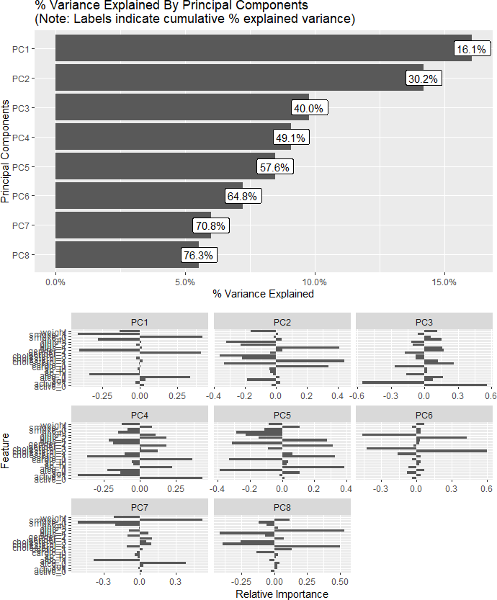

Output of plot_prcomp(df). Image by author.
The package documentation³ contains the full list of the available functions.

GGally
GGally⁴ extends the popular ggplot2 plotting package by providing features to automatically visualize datasets and combine geometric objects.
In particular, one may leverage the ggpairs⁵ function on a dataset (e.g. ggpairs(df)) and obtain pairs plot showing the interactions of each variable with each of the others:
#install.packages("GGally") library(GGally)

# change plot size (optional) options(repr.plot.width = 20, repr.plot.height = 10)

df %>%
select("age", "cholesterol", "height", "weight") %>% ggpairs(mapping = aes(color = df$cardio, alpha = 0.5))



Image by author.
ggpairs offers an easy way to generate plots for descriptive analysis, proving useful to spot outliers, observe distributions and visually inspect differences between groups.
In our example, we chose for simplicity to generate plots for only four variables of the dataset (df %>% select("age", "cholesterol", "height", "weight")), and we applied different colours based on the presence of cardiovascular disease through
the ggplot2 aesthetics (aes(color = df$cardio, alpha = 0.5)).
The charts can be further customized by specifying the types of plots desired in the lower, upper and diagonal panels⁵.

SmartEDA
SmartEDA⁶ is a powerful toolkit that automates most of EDA tasks by providing functions for:
    - Descriptive statistics
    - Data visualisation
    - Custom tables
    - HTML reports
Similarly to what we did with DataExplorer, we can generate a complete HTML report by calling the ExpReport function. We can specify a response variable Target to include further bivariate analyses to the report:
This snippet produces a file named Report.html in the working directory. When opened with a browser, it looks as follows:

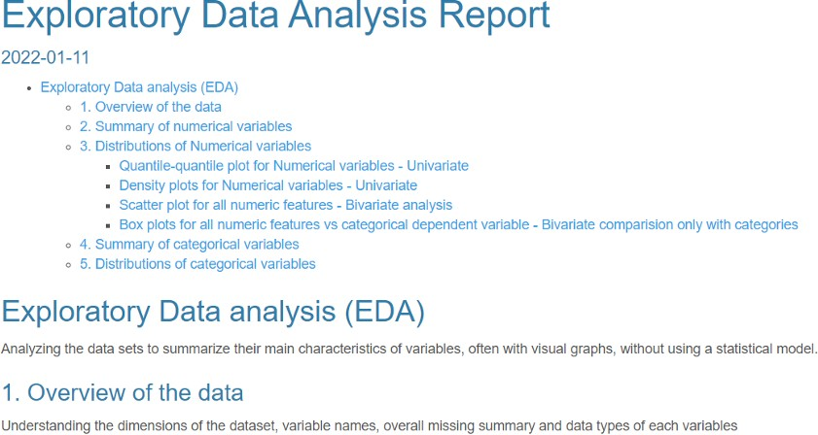

The early part of the HTML report, comprehensive of table of contents. Image by author.
The report contains a complete set of exploratory analyses, and it can be generated without coding efforts.
Additional package functions for specific tasks are reported as example:
    - ExpData(data=df, type=1) displays an overview over a dataset:
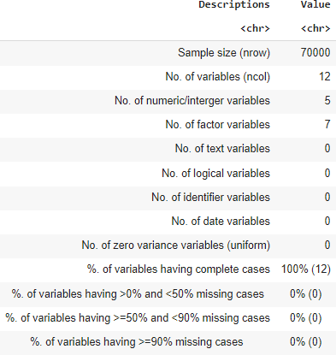
Output of ExpData(data=df, type=1). Image by author.
    - ExpData(data=df, type=2) shows the data structure:

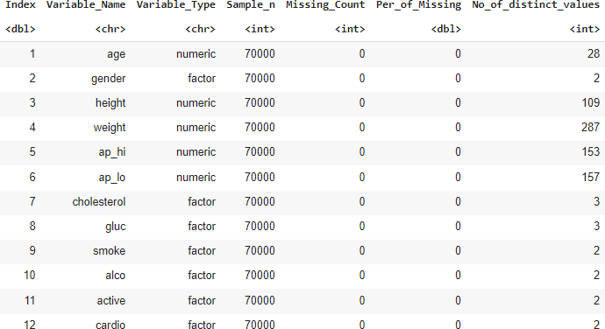

Output of ExpData(data=df, type=2). Image by author.
    - ExpCatStat(df, Target="cardio", Pclass="1", plot=TRUE) for variable importance based on information value:
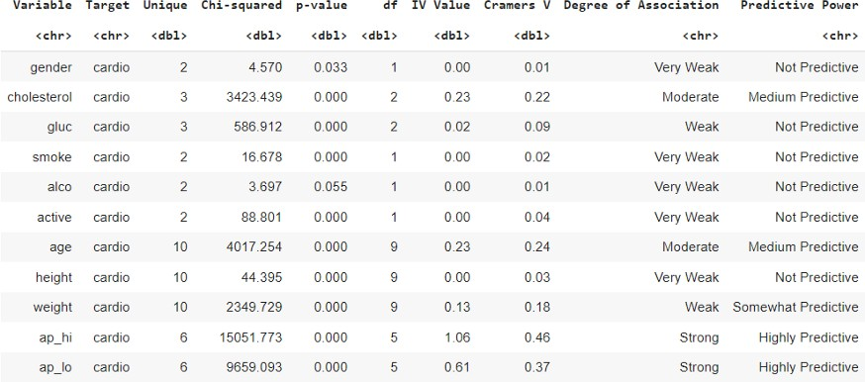
Output of ExpCatStat(df, Target="cardio", Pclass="1", plot=TRUE). Image by author.
From this output, we gain information on the degree of association and predictive power of each covariate towards the cardiovascular disease (Target="cardio"). In particular, we can observe that the systolic and diastolic blood pressure are categorized as “Highly predictive” of cardiovascular disease, while cholesterol and age appear to be “Medium predictive”. The function also produces a plot of the information value of each variable:

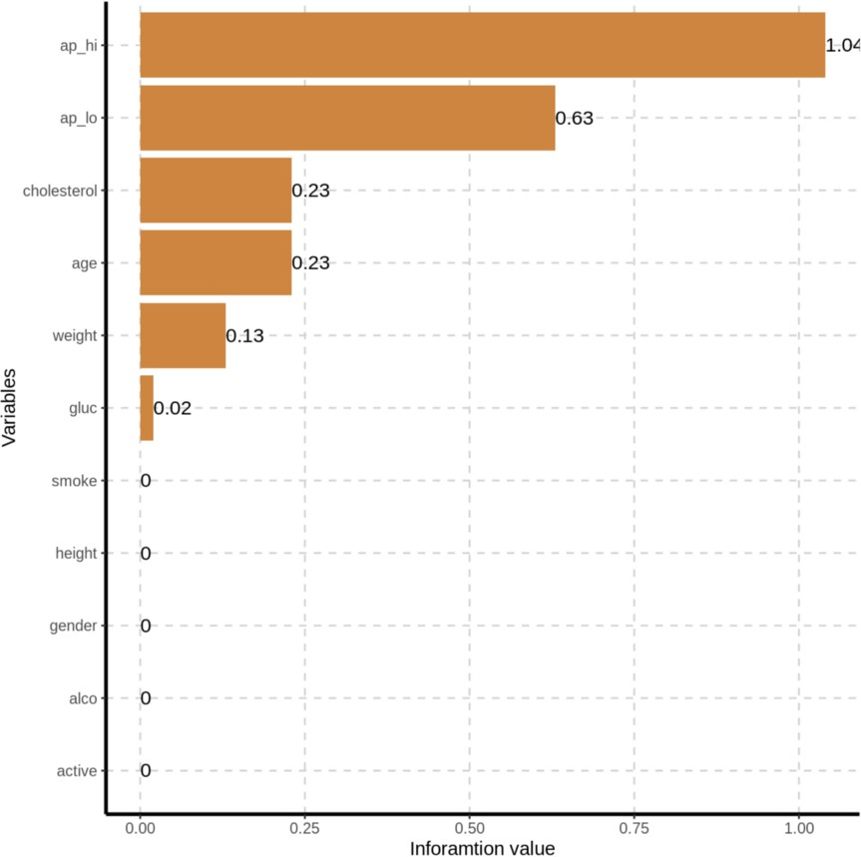

Output of ExpCatStat(df, Target="cardio", Pclass="1", plot=TRUE). Image by author.
The package provides a variety of handy functions to generate plots and tables. The full list of available functions, together with examples, is available in the package documentation⁷, or GitHub⁶.

tableone
In biomedical journal papers, the Table 1 provides a quantitative breakdown of baseline patients characteristics. The tableone package aims at producing the typical Table
1 (hence the name) from research publications.
Before using it, we perform an optional pre-processing step to make the categories and column names more readable:
df <-
df %>%
# modify factor levels mutate_at(c("cholesterol", "gluc"), ~ recode(.,
"1" = "normal",
"2" = "above normal", "3" = "well above
normal")

) %>%
mutate_at(c("smoke", "alco", "active", "cardio"), ~ recode(.,
"0" =

"no",

"yes")
) %>%
mutate_at(c("gender"), ~ recode(.,
"1" = "woman",
"2" = "male")

"1" =

) %>%
# rename columns rename(
"systolic blood pressure" = "ap_hi", "diastolic blood pressure" = "ap_lo", "glucose" = "gluc",
"smoking" = "smoke", "alcohol" = "alco",
"physical activity" = "active", "cardiovascular disease" = "cardio"
)

head(df)

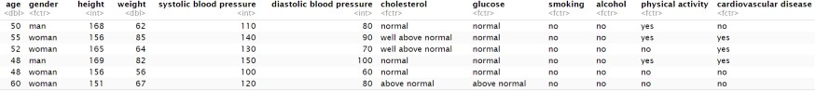
Image by author
We now use the CreateTableOne function to generate an object that summarizes all baseline variables, both continuous and categorical, optionally stratifying by one or more variables and performing statistical tests. In our case, we decide to stratify by the presence of cardiovascular disease through the strata argument:
# install.packages("tableone") library(tableone)

# we perform a stratification based on the presence of cardiovascular disease
tableOne <- CreateTableOne(vars = colnames(select(df, -"cardiovascular disease")),
strata = c("cardiovascular disease"), data = df)

# we pass a list of continuous variables not normally distributed in the "nonnormal" argument
print(
tableOne,
nonnormal = c("age", "weight", "height", "systolic blood pressure", "diastolic blood pressure"),
showAllLevels = TRUE)

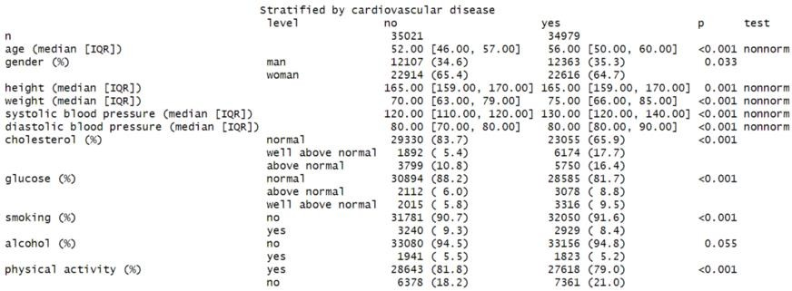
Output of print(tableOne). Image by author.
From the table, it can be observed that:
- Categorical variables are represented as counts and percentages.
- Continuous variables are displayed as:
  - In case of normal distribution: mean and standard deviation.
  - In case of non-normal distribution: median and interquartile ranges.
The table provides immediate and intuitive overview of the baseline characteristics stratified by cardiovascular disease.
It is possible to see the categorical or continous variables only, by accessing respectively to the CatTable and ContTable elements of the TableOne object. For example:
# categorical part only df$CatTable
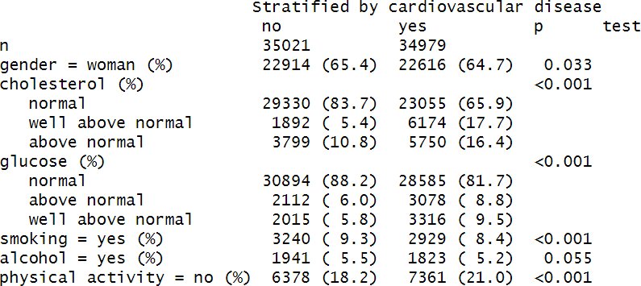

Conclusions
Output of df$CatTable. Image by author.

In this post, we used four R packages that accomplish different EDA tasks, from summary tables to detailed HTML reports, and significantly ease the exploration of a new dataset.
R offers several packages with features that neatly and quickly summarize numerical and categorical data. We name a
few: skimr⁹, Hmisc¹⁰, desctable¹¹, summarytools¹², dlookr¹³.
Putatunda et al.¹⁴ (2019) shared an insightful comparison between different packages providing EDA capabilities and available in CRAN:

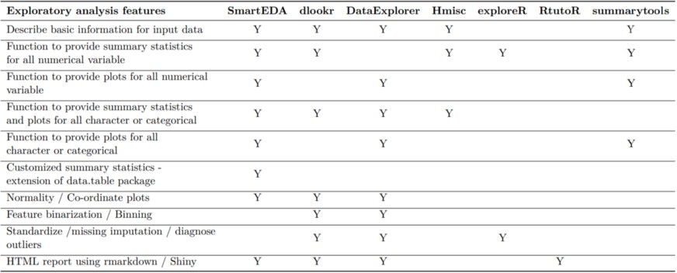
Comparison between the EDA features of different R packages. From Putatunda et al.¹⁴ (2019).
For curiosity, we can observe the number of downloads for the cited packages in the last year (2021) as follows:
# install.packages("dlstats") library("dlstats")

stats <- cran_stats(c("SmartEDA", "DataExplorer", "tableone", "GGally", "Hmisc",
"exploreR", "dlookr", "desctable",
"summarytools"))

stats %>%
filter(start >= "2021-01-01" & end < "2022-01-01") %>% select(package, downloads) %>%
group_by(package) %>%
summarize(downloads = sum(downloads)) %>% arrange(desc(downloads))

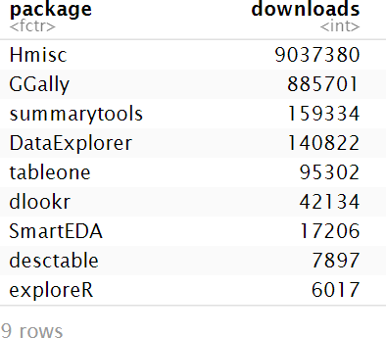
Image by author.
We can also observe the packages download trend over time:
# log10 scale is used as the difference between downloads is comparatively large
ggplot(stats, aes(end, log10(downloads), group=package, color=package)) +
geom_line()

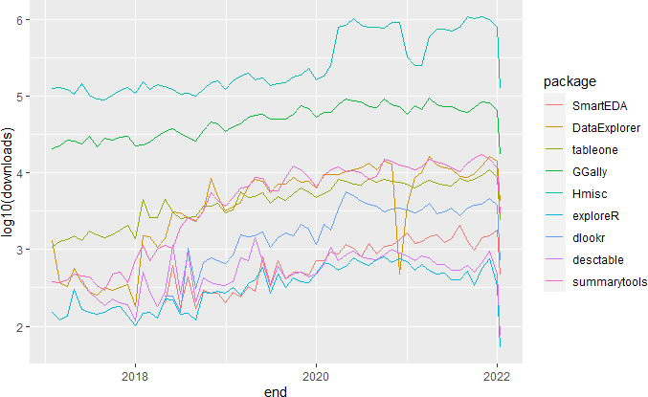

References
Image by author.

- kaggle.com/sulianova/cardiovascular-disease-dataset
- rdocumentation.org/packages/base/versions/3.6.2/topics/summary
- cran.r-project.org/package=DataExplorer
- cran.r-project.org/package=GGally
- rdocumentation.org/packages/GGally/versions/1.5.0/topics/ggpairs
- github.com/daya6489/SmartEDA
- cran.r-project.org/package=SmartEDA
- cran.r-project.org/package=tableone
- cran.r-project.org/package=skimr
- cran.r-project.org/package=Hmisc
- cran.r-project.org/package=desctable
- cran.r-project.org/package=summarytools
- cran.r-project.org/package=dlookr
- Putatunda, Sayan and Ubrangala, Dayananda and Rama, Kiran and Kondapalli, Ravi, “SmartEDA: An R Package for Automated Exploratory Data Analysis”, Journal of Open Source Software, vol. 4, 2019, link.

